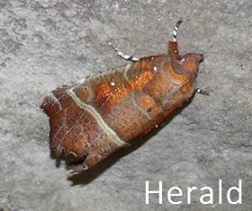
Scottish Hibernating Moth Survey
A number of moths overwinter as adults in the UK, but only two: The Herald and The Tissue are regularly found during this period. In Scotland, The Tissue has only ever been found at two sites and so unlikely to be found, but extremely interesting if it were. This survey is looking to understand more about the sites used for hibernating Heralds, the numbers present and some details about the sites themselves.
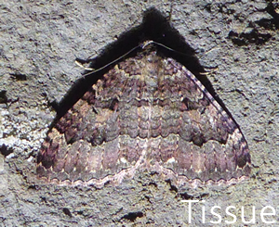
Both species of moth are frequently to be found on the ceilings and often the walls of almost dark, typically underground rooms, caves and mines. It would be unusual to find them where any direct light falls nor beyond the twilight zone into pitch black areas of these sites. Depending on the site they are most likely to be found in a region between 5 and 25 metres from the entrance. Like bats they like stable, low temperatures and relatively high humidity.
They are each about 25mm in length. The Heralds, as well as being much the more common, are easier to spot as they are more ‘three dimentional’ and so catch the light of a torch and also cast a shaddow making them more apparent. Tissues are relatively easy to miss as they rest close to the surface and often on the underside of ledges.
Overleaf there is a recording form which can be returned by email to hibernatingheralds@eastscotland-butterflies.org.uk.
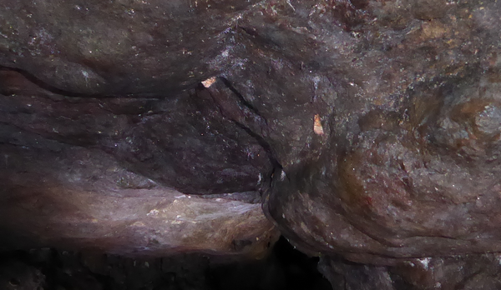
If you can, please include some photographs of the site (external and internal).
Two Herald moths in typical hibernating positions

Observer name: | Email Address: | Phone number:

Date | Location Name | Grid reference | Site type description | Species | Quantity | Are ceiling/ walls dry, damp or wet | Is there condensation on the moths? | Other species present e.g. cave spider, butterflies
01/12/2016 | Seafield Cave, Fife | NT277881 | Coastal cave with 4m high entrance which can flood at high tide | Herald | 7 | Damp | No | Cave spiders

Note: By submitting this form I give Butterfly Conservation (BC) permission to use and incorporate the information into data collations, and to make copies of these available to others by a variety of means to further the conservation of butterflies in accordance with BC’s published policies. I waive my right to be identified as the author of this information & to object to the manner in which it is used.

